FitFlex – Your Personal Fitness Companion

Project Documentation

1. Title Page

Project Title: FitFlex – Your Personal Fitness Companion

Developed By:

Asifa Zohra (Team Leader)

[Sadhana.M]

[Sumaiya Tabassum]

[Padmapriya]

Institution: CTTE College, BCA Department

Program: Naan Mudhalvan

Date: [19/09/2025]

2. Abstract

FitFlex is a smart fitness application designed to help users stay healthy and active. It provides personalized workout plans, diet recommendations, and progress tracking. The app simplifies fitness for beginners and motivates consistent effort through reminders, interactive charts, and tips.

3. Introduction

Modern lifestyles often make it hard to maintain regular fitness routines. FitFlex bridges this gap by offering a user-friendly platform to track workouts, plan meals, and monitor overall wellness. The project showcases teamwork, UI/UX design, and coding skills gained during the Naan Mudhalvan program.

4. Objectives

To create an easy-to-use fitness companion app.

To provide customized workout and diet recommendations.

To track users’ progress through visual analytics.

To encourage healthy habits through reminders and motivational prompts.

5. System Requirements

Hardware:

Processor: Intel i3 or higher

RAM: 4 GB or more

Storage: 2 GB free space

Software:

Operating System: Windows / macOS / Android

Languages & Frameworks: HTML, CSS, JavaScript / React (Frontend), Node.js (Backend)

Database: MySQL or MongoDB

Tools: VS Code, GitHub

6. Methodology / Procedure

1. Planning & Research – Studied fitness app trends, defined features.

2. Design – Created wireframes and UI mockups.

3. Development –

Frontend: Built user interface with HTML/CSS/React.

Backend: Configured Node.js server and database.

4. Integration – Connected frontend with backend API.

5. Testing – Performed unit and user testing for bugs.

6. Deployment – Hosted project on [platform or local server].

7. Presentation – Prepared slides and demonstration video.

7. Features

Personalized workout plans (beginner, intermediate, advanced).

Diet tips and calorie calculator.

Daily reminders and motivational quotes.

Progress charts for workouts and weight.

User authentication and secure data storage.

8. Screenshots / UI Samples

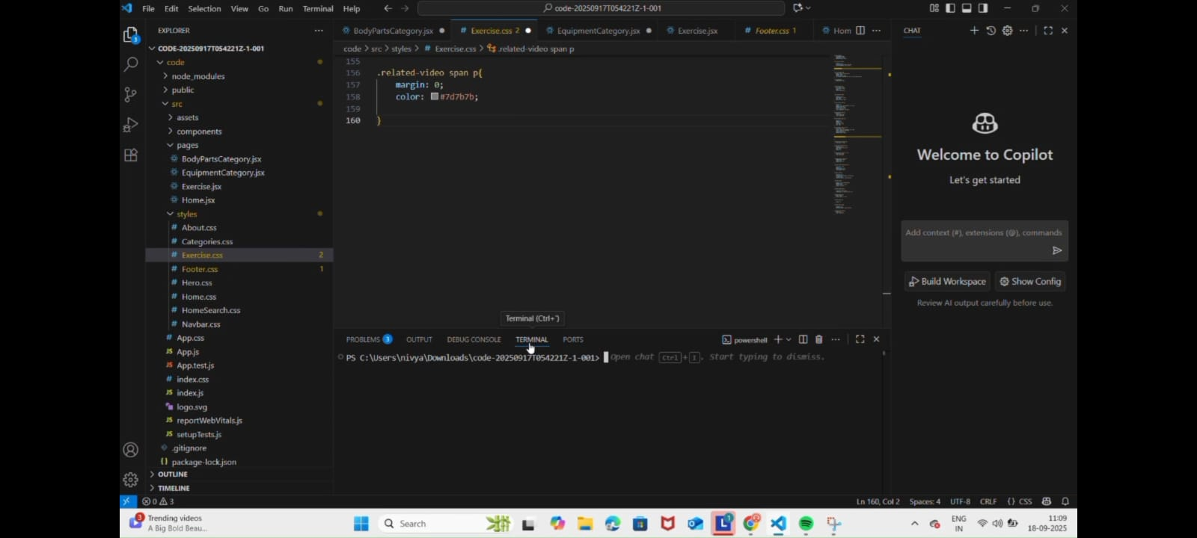

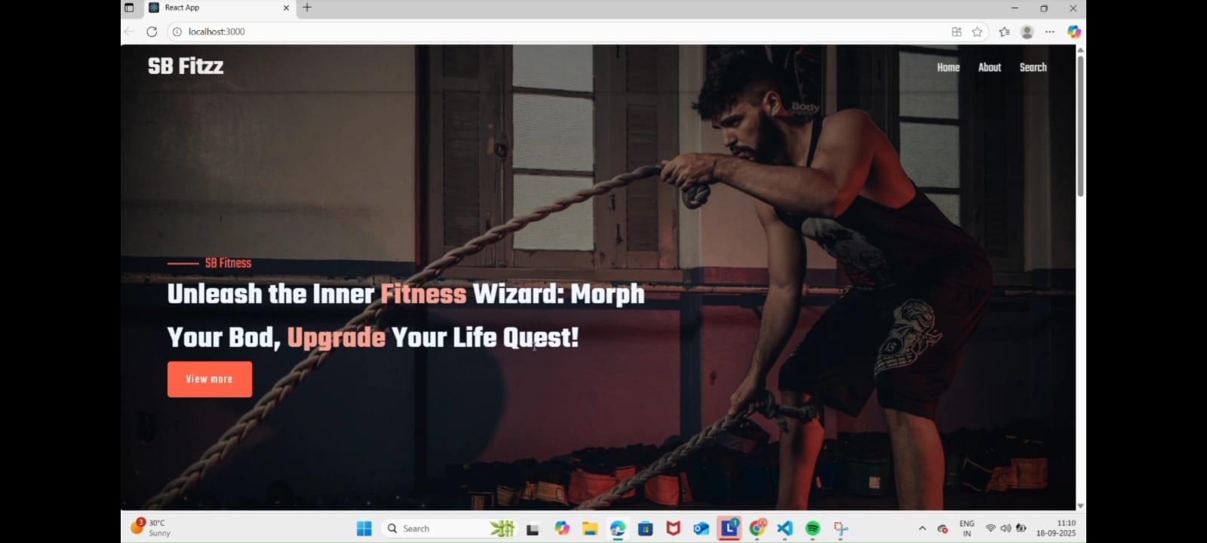

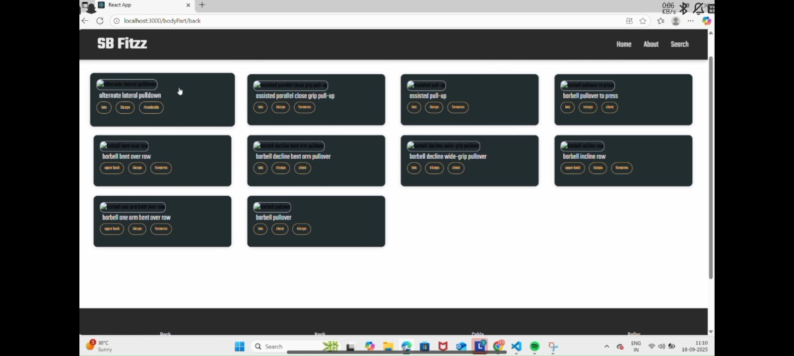

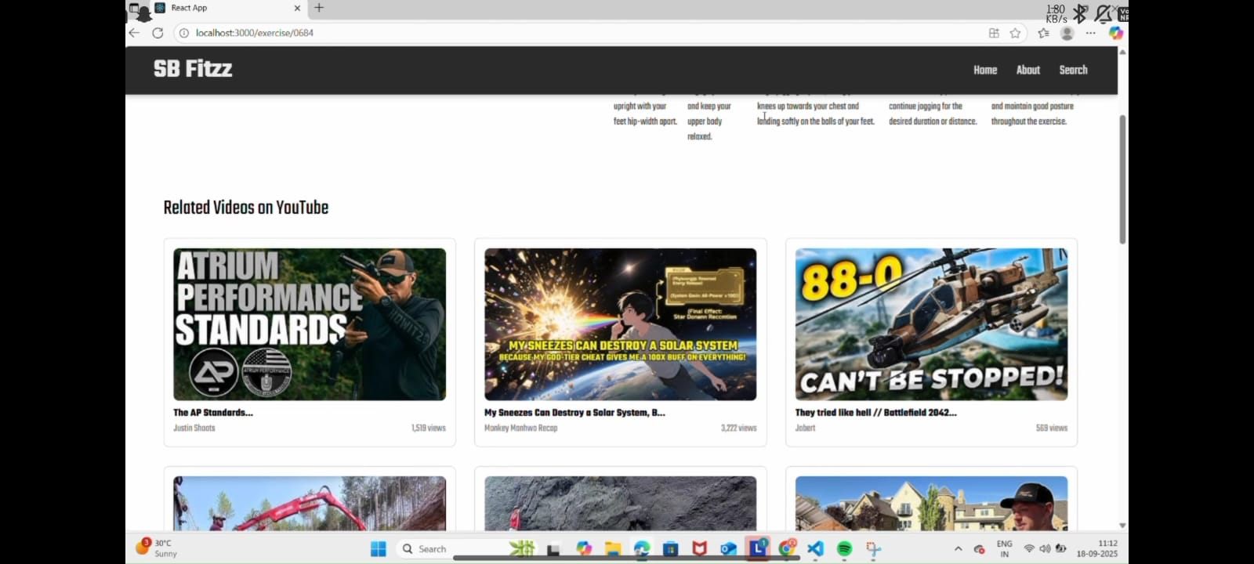

9. Results and Discussion

FitFlex successfully demonstrated how technology can simplify fitness tracking. Testing showed improved user motivation and ease of access compared to manual tracking.

10. Future Enhancements

Integration with wearable devices (smartwatches, fitness bands).

AI-based workout suggestions.

Social features for community challenges.

Multi-language support.

11. Conclusion

FitFlex provides a comprehensive, beginner-friendly fitness companion that combines health insights with modern tech. It represents our teamwork, problem-solving skills, and the practical application of BCA course concepts.